LINUX
Linux is a case sensitive language.

DIRECTORY STRUCTURE
/ The directory called "root." It is the starting point for the file system hierarchy. Note that
this is not related to the root, or superuser, account.
/bin Binaries and other executable programs.
/etc System configuration files.
/home Home directories.
/opt Optional or third party software.
/tmp Temporary space, typically cleared on reboot.
/usr User related programs.
/var Variable data, most notably log files.
/ The directory called "root." It is the starting point for the file system hierarchy.
Note that this is not related to the root, or superuser, account.
/bin Binaries and other executable programs.
/boot Files needed to boot the operating system.
/cdrom Mount point for CD-ROMs.
/cgroup Control Groups hierarchy.
/dev Device files, typically controlled by the operating system and the system
administrators.
/etc System configuration files.
/export Shared file systems. Most commonly found on Solaris systems.
/home Home directories.
/lib System Libraries.
/lib64 System Libraries, 64 bit.
/lost+found Used by the file system to store recovered files after a file system check has
been performed.
/media Used to mount removable media like CD-ROMs.
/mnt Used to mount external file systems.
/opt Optional or third party software.
/proc Provides information about running processes.
/root The home directory for the root account.
/sbin System administration binaries.
/selinux Used to display information about SELinux.
/srv Contains data which is served by the system.
/srv/www Web server files.
/srv/ftp FTP files.
/sys Used to display and sometimes configure the devices and busses known to the
Linux kernel.
/tmp Temporary space, typically cleared on reboot. This directory can be used by the
OS and users alike.
/usr User related programs, libraries, and documentation. The sub-directories in /usr
relate to those described above and below.
/usr/bin Binaries and other executable programs.
/usr/lib Libraries.
/usr/local Locally installed software that is not part of the base operating system.
/usr/sbin System administration binaries.
/var Variable data, most notably log files.
/var/log Log files.
/devices Device files, typically controlled by the operating system and the system
administrators.
/kernel Kernel and kernel modules. (Solaris)
/platform Platform specific files. (Solaris)
/rpool ZFS root pool directory. (Solaris)
/net Used to mount external file systems. (HP-UX)
/nfs4 Used to mount the Federated File System domain root. (Solaris)
/stand Files needed to boot HP-UX.
/usr/local/apache/bin The application's binaries and other executable programs.
/usr/local/apache/etc Configuration files for the application.
/usr/local/apache/lib Application libraries.
/usr/local/apache/logs Application log files
/opt/apache/bin The application's binaries and other executable programs.
/opt/apache/etc Configuration files for the application.
/opt/apache/lib Application libraries.
/opt/apache/logs Application log files
/etc/opt/apache Configuration files for the application.
/opt/apache/bin The application's binaries and other executable programs.
/opt/apache/lib Application libraries.
/var/opt/apache Application log files
/opt/acme Company top level directory.
/opt/acme/bin Binary programs created by or installed by the Acme Corporation/opt/acme Company top level directory.
/opt/acme/apache The top level directory for Acme's installation of apache.
/opt/acme/apache/bin The apache binary programs.
/opt/web-team The web support team's top level directory.
/opt/acme/web-team The web support team's top level directory.
/usr/local/acme/web-team The web support team's top level directory.
Essential Linux commands
pwd Present Working Directory
cd [dir] Change Directory -> changed the current directory to the dir.
ls Lists directory contents
ls -l Lists directory contents using a
cat Concatnates and displays file
clear (or) ctrl+l clears the screen
man command Displays the online manual for command
- space To enter the next page of the online manual
- q quit from the online manual
exit Exits the shell or current session.
whoami my name
uname your name
mkdir To create a new directory(Folder)
touch To create a new File
rm To remove (or) delete files
rmdir To remove directories if directories are empty
rm -r To remove directories with files
mv Move files from one location to the other
stat To know the properties of the particular file or Directory.
ls -l To display the log list of the particular file
cat To display the content inside the file
nanoTo edit the content inside the file
cp copy the content from one file to another
echo Used to print the exactly return statement
Fi
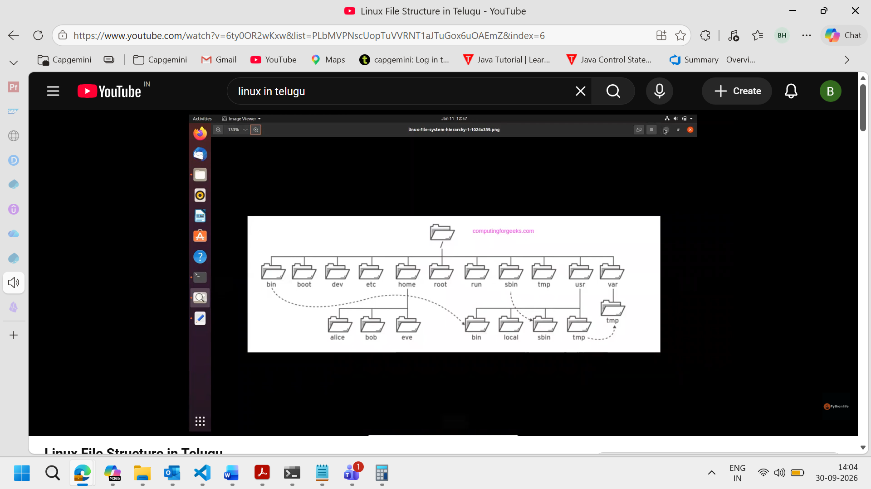
Linux file structure

Linux file permissions
If file starts with
- File
d Directory
l Links
File permissions
Consists of 9 letters
rw-r--r—
r Read
w Write
x Execute
First 3 indicates User permissions
second 3 indicates group permissions
Third 3 indicates everyone permissions
Chmod To modify the file permissions
r 4
w 2
x 1
Help commands
- man command To get the manual for the command
- if we know the command partially then type the command and press tab twice
- command --help To know the operation of the particular command
- apropos If we don’t know any thing

Pipe and grep
| Pipe -> 2 or more commands pass
head Header
tail footer
wc word count
uniq to get uniq elements
sort to sort the elements in the file
bhari@LIN-5CG1196S54:~/documents$ cat cars.txt | wc
11 23 194
11 No.of lines
23 No.of words
194 No.of characters/bytes
Grep Global search for regular expression and printout
Ex: grep “word you want to search” file name
To know the line number of the particular search -n
Ex: grep “word you want to search” file name -n
** if we want the words except the word you want to search -v
Cmd: grep “word you want to search” file name -v
- Irrespective of the case sensitive if we want to search the particular thing than we can use -i
Ex: grep “word you want to search” file name -i
tee takes the input dispalys and send to the next file.
Creating and Deleting users in Linux
Linux is a multiuser operating system
users Users in system
groups groups available
groups username user available in different groups
APT
APT stands for Advanced Package Tool.
It is a package management tool used in Ubuntu, Debian, and Debian-based Linux distributions to install, update, remove, and manage software packages.
Text editing
- In linux for text editing we will use nano, vi and vim commands
- In vi command for editing the text we need to click i
- In vi command for the esc from the editing we need click : esc wq
Networking commands
Ping
Ifconfig
Resource viewing
$ > not as a root user
# root
df disk free
du disk usage
Shell scripting

- Used to perform the repetitive tasks
- Files can be created using .sh
- Need to enter the the path of the bash in the file using #!
- To execute the bash file ./file name
Variables and comments
Bash : interpreted
Ex: python is a interpreted language
# comments
2 types of variables in bash
1.System variables
Ex: pwd, cat, ls
2.user defined variables
Ex: x=10; y=20
In bash we will define variables with $ symbol
read is used to taken the input from the user

